**Overview:**

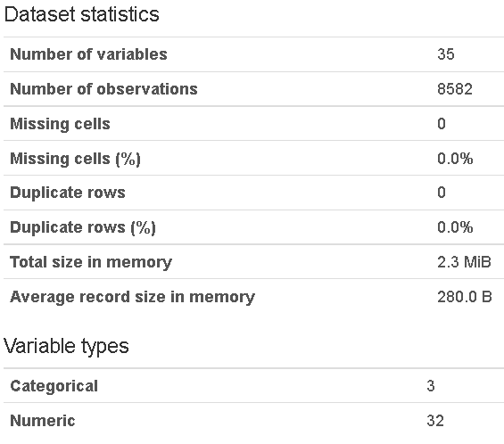

**Variables:**

* **Year**

Min: 2000, Max: 2016

* **g:** nbr of games played

High correlation: ws, bpm, vorp.gm, mpg.1, truesalary

(normalized)

* **ts:** True Shooting Percentage: A measurement of efficiency as a shooter in field goal attempts, three-point field goal attempts and free throws. Points/ [2*(Field Goals Attempted+0.44*Free Throws Attempted)]

High correlation with per, ws,ws.48,obpm,bpm,vorp.gm,offense

n

* **x3par:** 3-point attempt rate: 3PA/FGA (3-pointer-attempts vs field goal attempts, incl. both 2 and 3 point field goal attempts)

High correlation: orb.,trb.,bbref.pos,height,weight,rounded.position

* **ftr:** Free Throw rate: FT/FGA ; Free throws made/Field goal attempts)

High correlation with drb

n

* **orb:** (Offensive Rebound Percentage): A measurement of the percentage of offensive rebounds a player secures that are available to his team. Formula: 100 * [Player ORB * (Team Minutes / 5)] / [Player Minutes * (Team ORB + Opponent DRB)]

High correlation: x3par,drb,trb,ast,blk,bbref.pos,height,weight,rounded.position

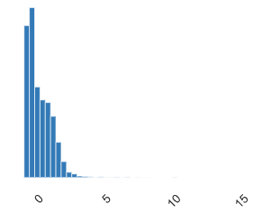

**Only important relevant variables stats:**

**Selected** has high correlation with ws,vorp.gm and truesalary, it contains 426 all-star apperarences

* **Age**

Mean: 26.8644838, Min: 18, Max:44

High correlation: yrs.experience

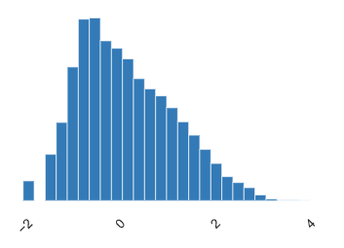

* **per:** Player efficiency rating: sums up all a player's positive accomplishments, subtracts the negative accomplishments, and returns a per-minute rating of a player's performance

Mean: 12.40221394, Min:-64.6, Max: 129.1

High correlation: ts,ws,ws.48,obpm,bpm,vorp.gm,mpg.1,truesalary

* **truesalary:** player salary

Mean: 4130737.687, Min: 600000, Max: 36700000

High correlation: g,per,ws,ws.48,obpm,bpm,vorp.gm,mpg.1

* **mpg.1:** minutes played per game

Mean: 20.10920531, Min: 0.7, Max : 43.7

High correlation: g,per,ws,obpm,bpm,vorp.gm,truesalary

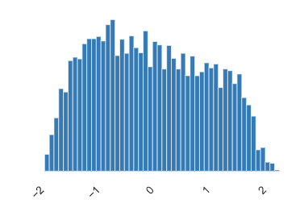

* **yrs.experience:** nbr of years of experience

Mean: 4.746079815, Min: 0(14.8%), Max: 20

High correlation: age

* **height:**

Mean: 78.95909296, Min: 0, Max: 91

High correlation: x3par,orb,trb,ast,blk,bbref.pos,weight,rounded.position

* **vorp.gm:** Value over replacement player, from 'RealGM' Website

Mean: 0.5165579119, Min: -7.4, Max: 12.6

High correlation: g,per,ts,ws,ws.48,obpm,bpm,mpg.1,truesalary

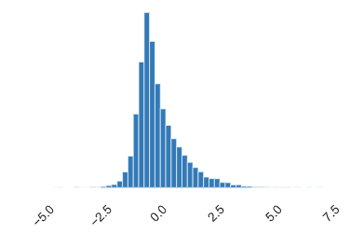

* **usg:** A measurement of the percentage of plays utilized by a player while he is in the game. Formula: 100 * [(FGA + 0.44 * FTA + TOV) * (Team Minutes / 5)] / [Player Minutes * Team FGA + 0.44 * Team FTA + Team TOV[]

Mean: 18.67086926, Min: 0, Max: 53.7

High correlation: per,ws.48,obpm,dbpm,bpm,offense,mpg.1,selected

**Interactions:**

n

**Correlation:**

The Spearman's rank correlation coefficient (ρ) is a measure of monotonic correlation between two variables, and is therefore better in catching nonlinear monotonic correlations than Pearson's r. It's value lies between -1 and +1, -1 indicating total negative monotonic correlation, 0 indicating no monotonic correlation and 1 indicating total positive monotonic correlation. To calculate ρ for two variables X and Y, one divides the covariance of the rank variables of X and Y by the product of their standard deviations.

n